import pandas as pd

data=pd.read_csv("ds_salaries.csv")

data.head()

data.shape

data.info()

data.isnull().sum()

data.job_title.unique()

data.describe()

from sklearn.preprocessing import LabelEncoder

column = "job_title"

data2=data.copy()

data[column] = LabelEncoder().fit_transform(data[column])

from matplotlib import pyplot as plt

import seaborn as sns

data['experience_level'].plot(kind='hist', bins=20, title='experience_level')

plt.gca().spines[['top', 'right',]].set_visible(False)

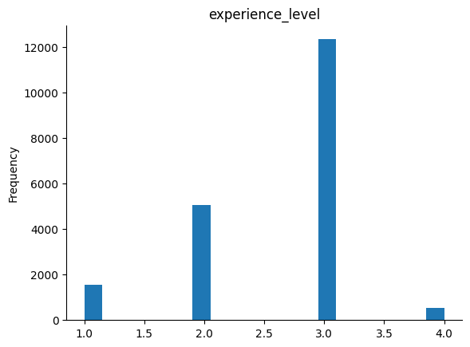

data.plot(kind='scatter', x='company_size', y='salary', s=32, alpha=.2)

plt.gca().spines[['top', 'right',]].set_visible(False)

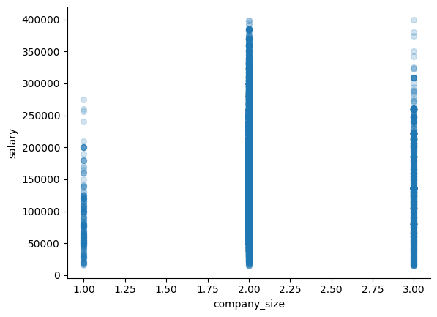

data.plot(kind='scatter', x='experience_level', y='salary', s=32, alpha=.2)

plt.gca().spines[['top', 'right',]].set_visible(False)

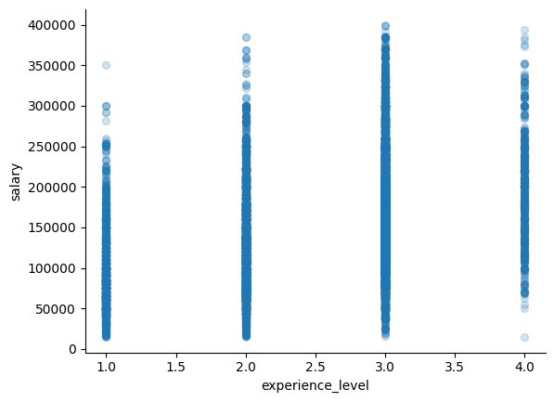

data.plot(kind='scatter', x='remote_ratio', y='salary', s=32, alpha=.2)

plt.gca().spines[['top', 'right',]].set_visible(False)

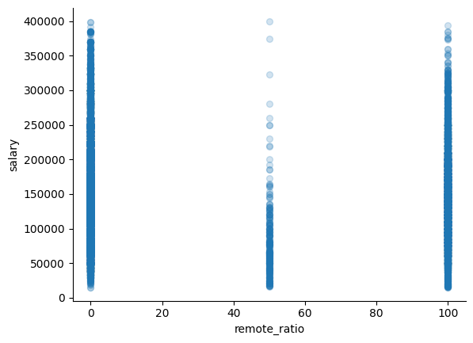

data2.plot(kind='scatter', x='job_title', y='salary', s=32, alpha=.2)

plt.gca().spines[['top', 'right',]].set_visible(False)

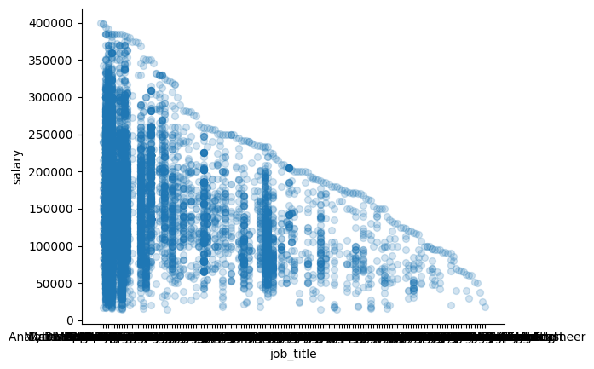

plt.figure(figsize=(12, 6))

ax = plt.gca()

ax.set_facecolor('#f0f0f0')

sns.lineplot(x='company_size', y='salary', hue='experience_level', data=data, palette=['limegreen', 'orange', 'royalblue', 'red'])

plt.title('Salary Trends Within Companies by Experience Level')

plt.xlabel('Company Size')

plt.ylabel('Salary (USD)')

plt.legend(title='Experience Level', loc='upper left')

plt.show()

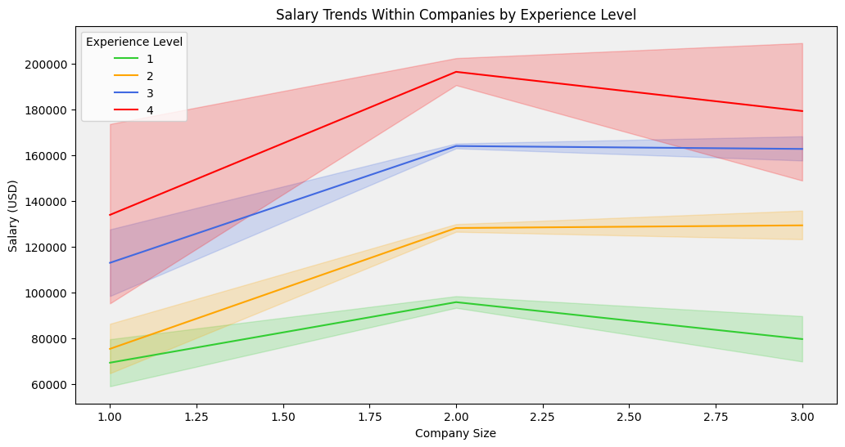

plt.figure(figsize=(12, 6))

ax = plt.gca()

ax.set_facecolor('#f0f0f0')

sns.lineplot(x='work_year', y='salary', hue='experience_level', data=data, palette=['limegreen', 'orange', 'royalblue', 'red'])

plt.title('Salary Trends Over Years by Experience Level')

plt.xlabel('Company Size')

plt.ylabel('Salary (USD)')

plt.legend(title='Experience Level', loc='upper left')

plt.show()

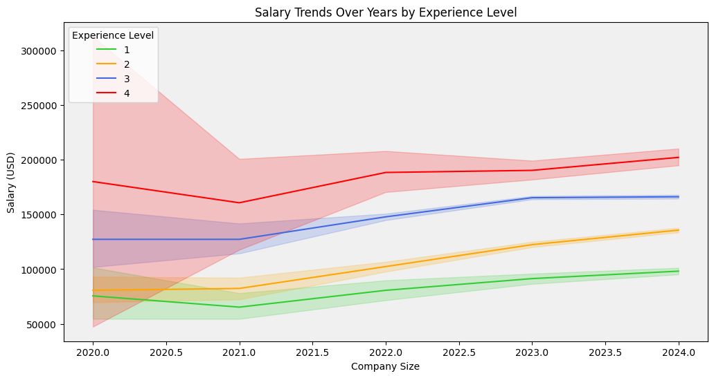

plt.figure(figsize=(12, 6))

avg_salary_by_title = data2.groupby('job_title')['salary'].mean().sort_values(ascending=False)[:10]

avg_salary_by_title.plot(kind='bar', color=['orange','red'], alpha=0.8)

plt.title('Top 10 Average Salaries by Job Title')

plt.xlabel('Job Title')

plt.ylabel('Average Salary (USD)')

plt.xticks(rotation=90)

plt.show()

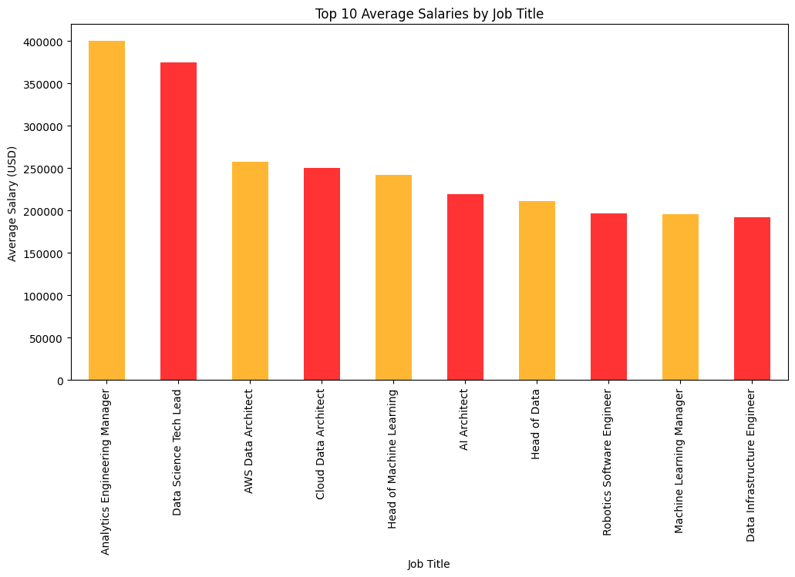

plt.figure(figsize=(10, 6))

sns.histplot(data['salary'], bins=20, color='violet', alpha=0.6)

plt.title('Histogram of Salary Distribution')

plt.xlabel('Salary (USD)')

plt.ylabel('Frequency')

plt.show()

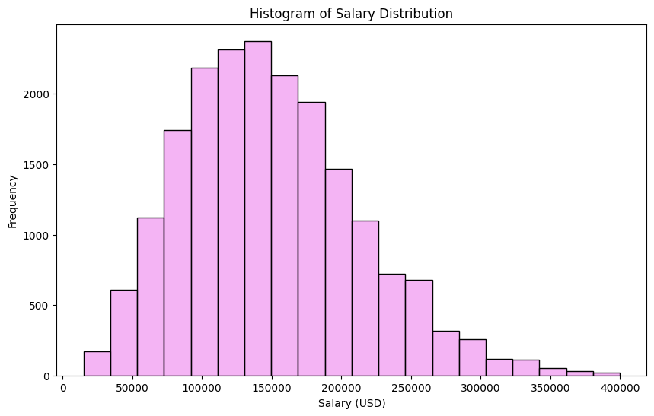

import plotly.express as px

def draw_remote_donut_chart(remote_status):

    remote_counts = remote_status.value_counts()

    labels = ['Fully Remote', 'Hybrid', 'In Office']

    values = [remote_counts.get(100), remote_counts.get(50), remote_counts.get(0)]

    fig = px.pie(names=labels, values=values, hole=0.3, title='Remote Status Distribution')

    colors = ['#1f77b4', '#ff7f0e', '#2ca02c']

    fig = px.pie(names=labels, values=values, hole=0.3, title='Remote Status Distribution',

                 color_discrete_sequence=colors, opacity=0.7)

    fig.show()

remote_status = data["remote_ratio"]

draw_remote_donut_chart(remote_status)

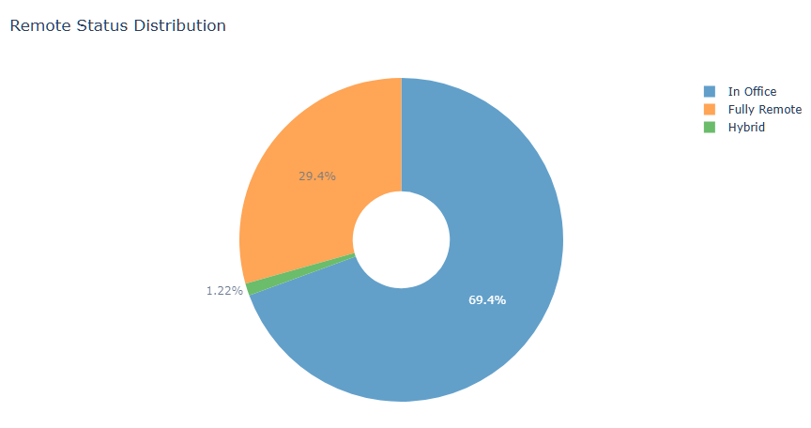

import numpy as np

from sklearn.model_selection import train_test_split

from sklearn.ensemble import RandomForestRegressor

from sklearn.preprocessing import StandardScaler

from sklearn.metrics import mean_absolute_error, mean_squared_error, r2_score

X = data.drop(columns=["salary"])

y = data["salary"]

X_train, X_test, y_train, y_test = train_test_split(X, y, test_size=0.25)

scaler = StandardScaler()

X_train_scaled = scaler.fit_transform(X_train)

X_test_scaled = scaler.transform(X_test)

model = RandomForestRegressor(n_estimators=1000, max_depth=10, min_samples_split=5, min_samples_leaf=2)

model.fit(X_train_scaled, y_train)

y_test_pred = model.predict(X_test_scaled)

mae = mean_absolute_error(y_test, y_test_pred)

print(f"Mean Absolute Error (MAE): {mae}")

mse = mean_squared_error(y_test, y_test_pred)

print(f"Mean Squared Error (MSE): {mse}")

rmse = np.sqrt(mse)

print(f"Root Mean Squared Error (RMSE): {rmse}")

r2 = r2_score(y_test, y_test_pred)

print(f"R-squared (R²): {r2}")

error_rate = abs(y_test - y_test_pred)/y_test

accuracy = 1 - error_rate

X_test["salary"] = y

X_test["prediction"] = y_test_pred

X_test["accuracy"] = accuracy

X_test["error_rate"] = error_rate

X_test

overall_accuracy = X_test["accuracy"].mean()

print(f"overall accuracy: {overall_accuracy}")

feature_importances = model.feature_importances_

features = X.columns

plt.figure(figsize=(12, 6))

sns.barplot(x=feature_importances, y=features)

plt.title("Feature Importances")

plt.xlabel("Importance")

plt.ylabel("Feature")

plt.show()

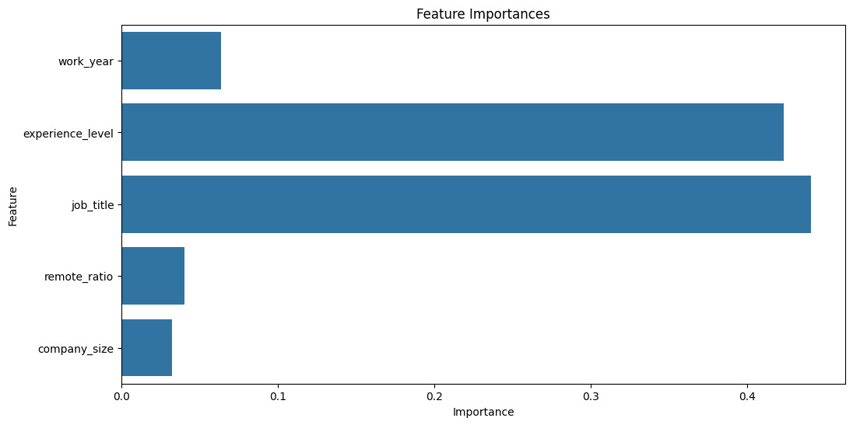

plt.figure(figsize=(10, 6))

plt.scatter(y_test, y_test_pred, alpha=0.3)

plt.plot([y.min(), y.max()], [y.min(), y.max()], 'r--', lw=2)

plt.xlabel("Actual Salary")

plt.ylabel("Predicted Salary")

plt.title("Actual vs Predicted Salary")

plt.show()

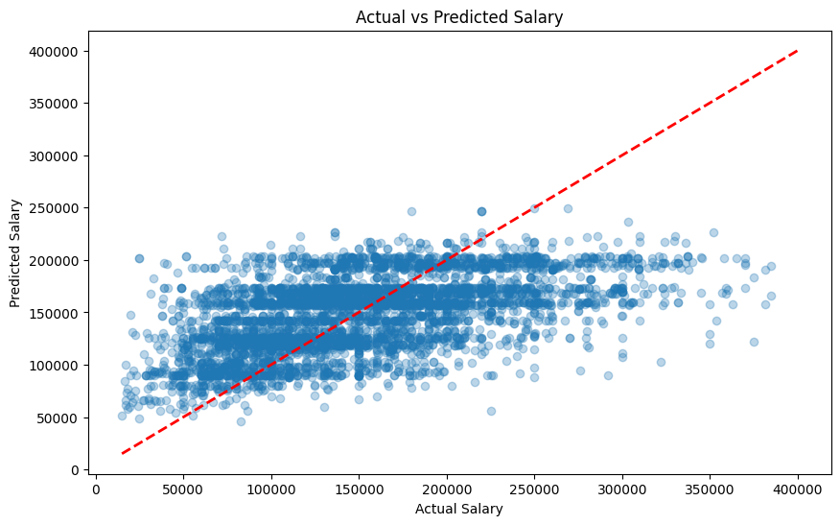

plt.figure(figsize=(10, 6))

sns.histplot(error_rate, bins=30, kde=True)

plt.xlabel("Error Rate")

plt.ylabel("Frequency")

plt.title("Distribution of Prediction Errors")

plt.show()

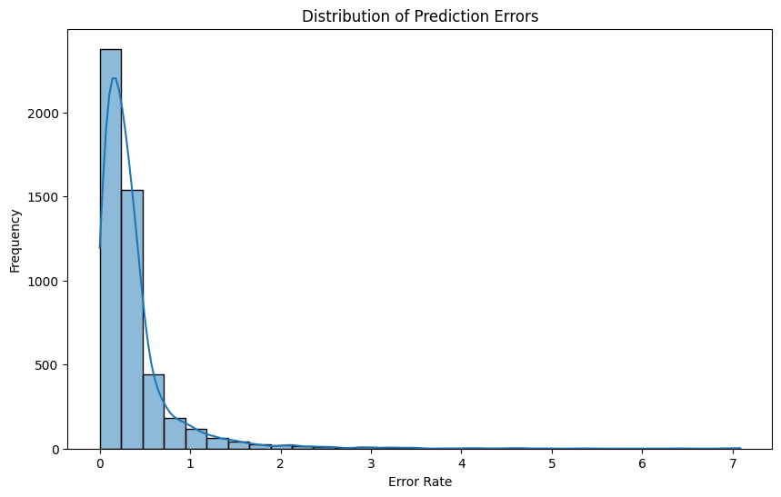

plt.figure(figsize=(10, 6))

sns.histplot(residuals, bins=30, kde=True)

plt.xlabel("Residuals (Actual - Predicted)")

plt.ylabel("Frequency")

plt.title("Distribution of Prediction Errors")

plt.show()

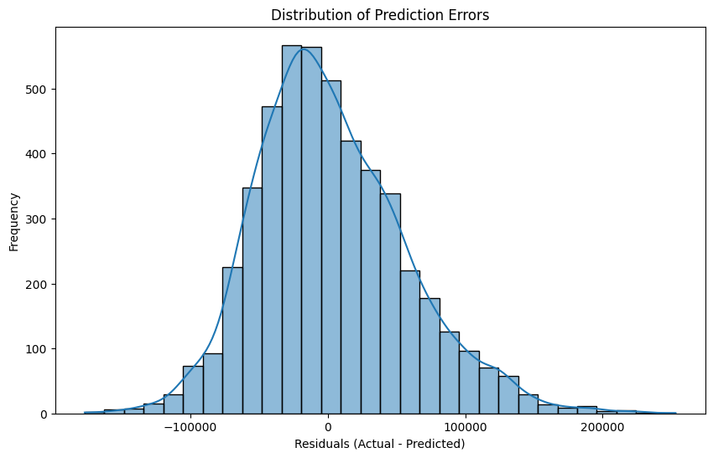

plt.figure(figsize=(12, 10))

correlation_matrix = data.corr()

sns.heatmap(correlation_matrix, annot=True, cmap='coolwarm', fmt=".2f")

plt.title("Feature Correlation Heatmap")

plt.show()

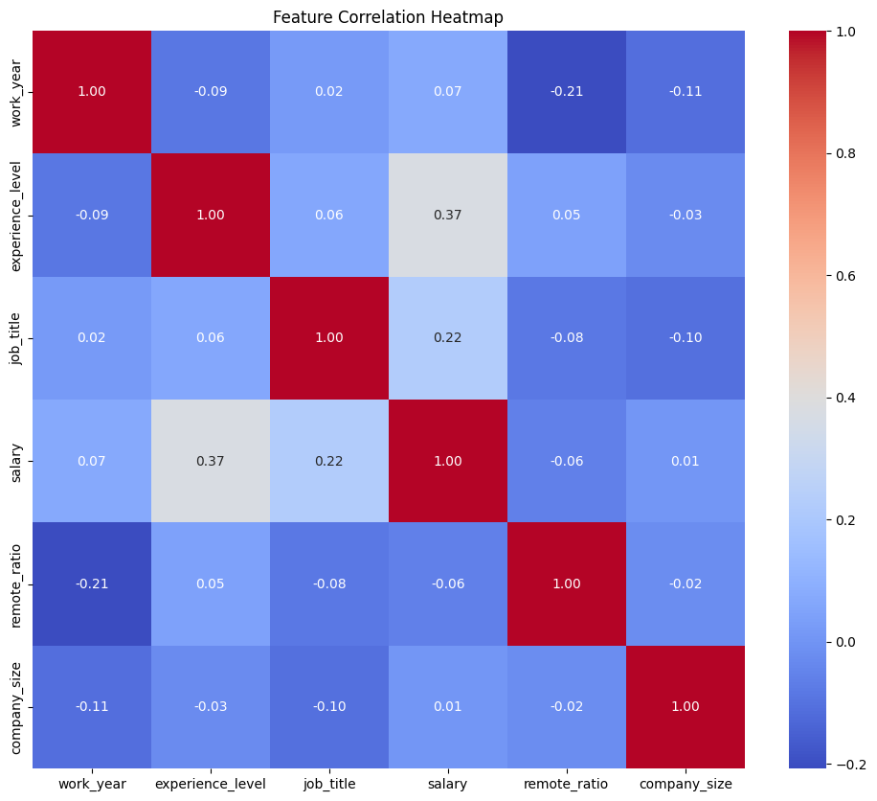

plt.figure(figsize=(12, 6))

sns.boxplot(data=[y_test, y_test_pred], notch=True)

plt.xticks([0, 1], ['Actual Salary', 'Predicted Salary'])

plt.title("Box Plot of Actual vs Predicted Salaries")

plt.show()

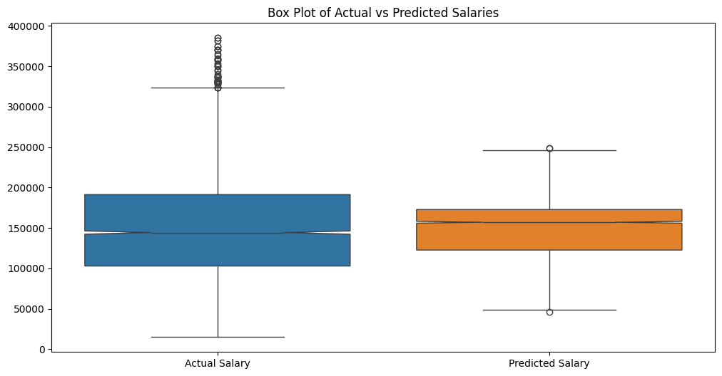

top_10_jobs = data2['job_title'].value_counts().nlargest(10).index

top_10_jobs_array = top_10_jobs.values

top_10_jobs2 = data['job_title'].value_counts().nlargest(10).index

filtered_data = X_test[X_test['job_title'].isin(top_10_jobs2)]

filtered_data['Error Rate'] = abs(filtered_data['salary'] - filtered_data['prediction']) / filtered_data['salary']

plt.figure(figsize=(12, 6))

ax = sns.boxplot(x=filtered_data[feature_to_plot], y=filtered_data['Error Rate'])

ax.set_xticklabels(top_10_jobs_array, rotation=90)

plt.xlabel("Job Title")

plt.ylabel("Error Rate")

plt.title(f"Error Rate by {feature_to_plot} (Top 10 Most Common)")

plt.show()

